Washington Township

Public School District

***NEW!!* Parent Single Sign-On**

Dear Parents/Guardians,

Next **Tuesday, April 12th, 2016**, the Washington Township School District will be enabling single sign-on access to the PowerSchool Parent Portal. This access will allow you to view each of your students’ information through the use of one unique login**. *Whether you have one or more students, you must create a new login account to access the Parent Portal.***

To create the account, you will need your PowerSchool Access ID and password for each student you want to associate to your new parent account. Please note, these access IDs can no longer be used for logging in, they can only be used to associate students to the newly created single sign-on accounts.

Before creating your account, make sure you have all of your child(ren)’s access IDs.

Go to the Wash Twp

PowerSchool Login page:

**https://powerschool.wtps.or**

**g/public**

(

you can also always find the link on the

school website

–

[www.wtps.or](http://www.wtps.org/)

[g](http://www.wtps.org/)

[)](http://www.wtps.org/)

.

1.

Select Create Account

2.

You will get the screen to set up access to ALL

of your

students

•

Enter your First Name and Last Name

•

Enter an email address.

*Please note*

*–*

The email address must be unique. If

individual parents/guardians share the

same email address, only set up one

parent access account.

•

Create a user name (do not use your

email address).

•

Create a password (must be six

characters)

•

Enter the name of each student

,

your

access IDs for each student, and your

passwords for each student (note

–

these

are case sensitive). Then, select the

relationship you are to the student.

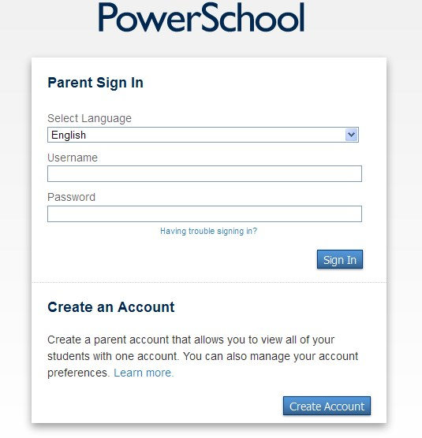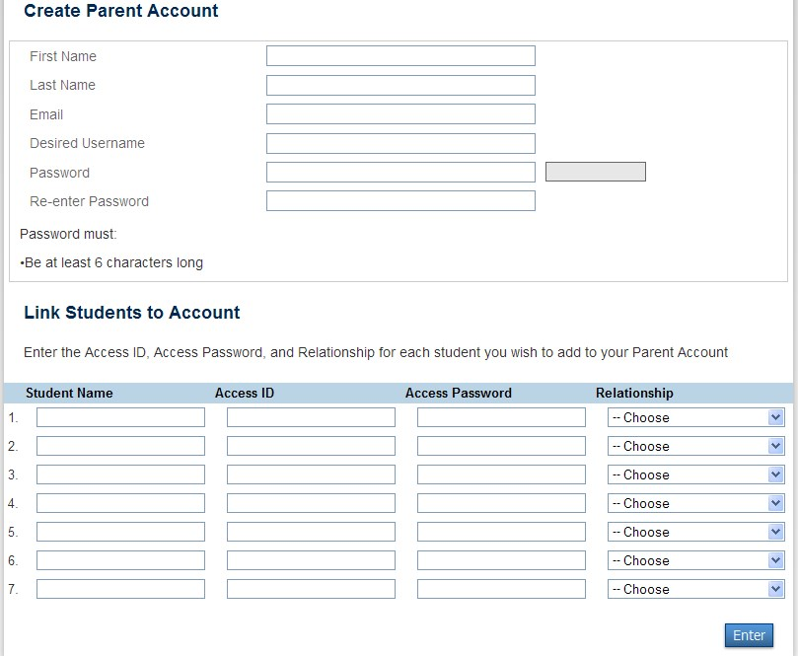

• Click Enter

3. When your account is successfully created, you will see this screen:

*Some notes on Single Sign On accounts…*

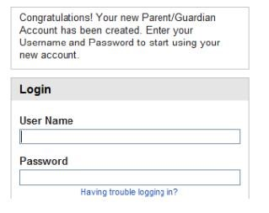

Parents can set up separate accounts if the parents have unique email addresses. Each parent/guardian can have his or her own account that includes his or her student(s).

If Parents/Guardians share the same account, ONLY ONE Parent/Guardian may access the account at a time.

**Do not set your browser to save passwords to this site! It may cause your password to appear not to work when logging in the next time.**

After successfully logging in, you will see a series of tabs under the PowerSchool logo listing your students. Select the appropriate name to view that student’s information.

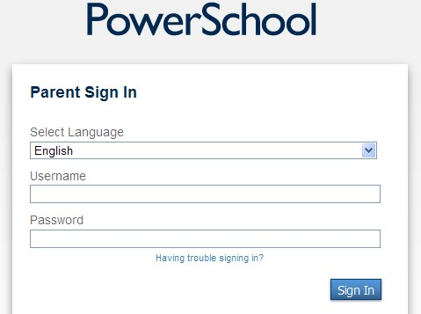

***What if you forget your***

***login information?***

On the login page, click “Having Trouble Logging In?”

If you forgot your password:

•

Fill in your User Name

•

Fill in your email Address

•

Click “Enter”

The system will authenticate your information and send you a security

token

with instructions on how to reset your password to the email

address listed. The security token is only valid for 30 minutes. You will

need to repeat the process if you do not reset the password

within 30 minutes.

If you forgot your user name:

•

Click on

the Forgot User Name tab

•

Enter your email address

•

Hit Enter

The system will authenticate your information and send you an

Email containing your user name.

